Policy statement 03: Complaints policy and procedures
Version: 2 | Approved: 10 December 2021 | Review: 10 December 2023

Previous version history
Version | Approved on | Changes
1 | 28 January 2019 | Substantial changes in line with Model Policy and Model Procedure on Complaint handling by charities and not-for-profits.

Purpose
- This policy is intended to ensure that Diversity ACT handles complaints fairly, efficiently and effectively.
- This policy provides guidance on our complaint management principles and processes to our staff and people who want to make a complaint.

Application
- This policy applies to all Diversity ACT staff receiving or managing complaints from the public and clients made to or about us regarding our services, staff or complaint handling process.
- In this document, ‘staff’ includes ‘members of the committee, volunteers, student placements, group members, visitors and paid employees’.

Definitions
- Complaint: An expression of dissatisfaction made to or about us, our services, staff or the handling of a complaint where a response or resolution is explicitly or implicitly expected or legally required. As well as complaints being made directly to our organisation, this could include complaints made on social media.
- Feedback: Opinions, comments and expressions of interest or concern, made directly or indirectly, explicitly or implicitly, to or about us, about our services or complaint handling system where a response is not explicitly or implicitly expected or legally required.

Background
- The Diversity ACT management committee is committed to a culture that values complaints and their effective resolution. This includes providing a safe, effective, efficient and fair process for the handling of complaints.

Guiding principles
- Our complaint handling system is based on the principles of fairness, accessibility, responsiveness, efficiency and integration into organisational culture.
- Principles on facilitating complaints:
  - People making complaints will be:
    - provided with information about our complaint handling process and how to access it
    - listened to, treated with respect by staff and actively involved in the complaint process where possible and appropriate
    - provided with reasons for our decision/s and any options for redress or review.
  - We will take all reasonable steps to ensure that people making complaints are not adversely affected because a complaint has been made by them or on their behalf.
  - Information about how and where complaints may be made to or about us is easily available on our website.
  - We accept anonymous complaints if there is a compelling reason to do so and will carry out a confidential investigation of the issues raised where there is enough information provided.
- Principles on responding to complaints:
  - We will promptly acknowledge receipt of complaints.
  - We will assess and prioritise complaints in accordance with the urgency and/or seriousness of the issues raised. If a matter concerns an immediate risk to safety or security the response will be immediate and will be escalated appropriately.
  - We will address each complaint with integrity and in an equitable, objective and unbiased manner.
  - We will protect the identity of people making complaints where this is practical and appropriate.
  - Material received will be held in compliance with Diversity ACT’s Privacy Policy. Personal information that identifies individuals will only be disclosed or used by us as permitted under the relevant privacy laws, secrecy provisions and any relevant confidentiality obligations.
- Principles on managing a complaint:
  - Complaints will be managed by the Diversity ACT management committee in line with this policy.
  - All parties must be given due process and natural justice.
  - If a complaint relates to a committee member, the committee will examine the matter in the absence of that party. In situations of particular sensitivity, an investigative panel made up of a sub-set of the committee may be convened with the agreement of the complainant.

Procedure
- Where a person has an issue that cannot be resolved immediately, the complainant may email or fill in a complaint form available at the Diversity Hub and on the website.
- The member of the management committee that receives the complaint will acknowledge receipt within three working days.
- Initial assessment: The management committee member will conduct an initial assessment within five working days of the complaint being received regarding whether the issue/s raised in the complaint is/are within our control. They will also consider the outcome/s sought by the complainant and, where there is more than one issue raised, determine whether each issue needs to be separately addressed. When determining how a complaint will be managed, they will consider:
  - how serious, complicated or urgent the complaint is
  - whether the complaint raises concerns about people’s health and safety
  - how the person making the complaint is being affected
  - the risks involved if resolution of the complaint is delayed
  - whether resolution requires the involvement of other organisations.
- If the management committee member receiving the complaint assesses it is simple, does not constitute a risk and has an outcome that does not require management committee agreement (such as giving an apology, explanation or additional information), they can respond appropriately and report at the next management committee meeting. Otherwise, the complaint will be investigated.
- Investigating the complaint: after assessing the complaint, the management committee member will refer it to the management committee or a subset thereof if appropriate. An investigative panel will be set up within ten working days of the complaint being received. That panel will:
  - gather information about the issue, person or area that the complaint is about, including interviewing the complainant and the subject(s) of the complaint
  - investigate the claims made in the complaint, with the process to be determined based on the specific situation
  - determine whether the complaint is unfounded or upheld
  - determine appropriate actions to be taken, tailored to each case and considering any statutory requirements
  - keep the complainant up-to-date on their progress, particularly if there are any delays.
- The investigative panel must provide a written report to the management committee, including recommended actions if the complaint has been upheld. This must be reviewed before or at the next management committee meeting, with actions completed within one month of receiving the report.
- The investigative panel must complete this work as quickly as is reasonable and, at most, within three months of the complaint being received.
- Determine outcome and provide reasons for decision: within ten working days of finalising its investigation, the investigative panel must contact the complainant and advise them:
  - the outcome of the complaint
  - the reason/s for their decision
  - the remedy or resolution/s that they have proposed or put in place.
- Documenting the complaint: We will keep records about:
  - how we managed the complaint
  - the outcome/s of the complaint (including whether it or any aspect of it was substantiated, any recommendations made to address problems identified and any decisions made on those recommendations), and
  - any outstanding actions to be followed up, including analysing any underlying or root causes.

Policy owner
Diversity ACT Management Committee

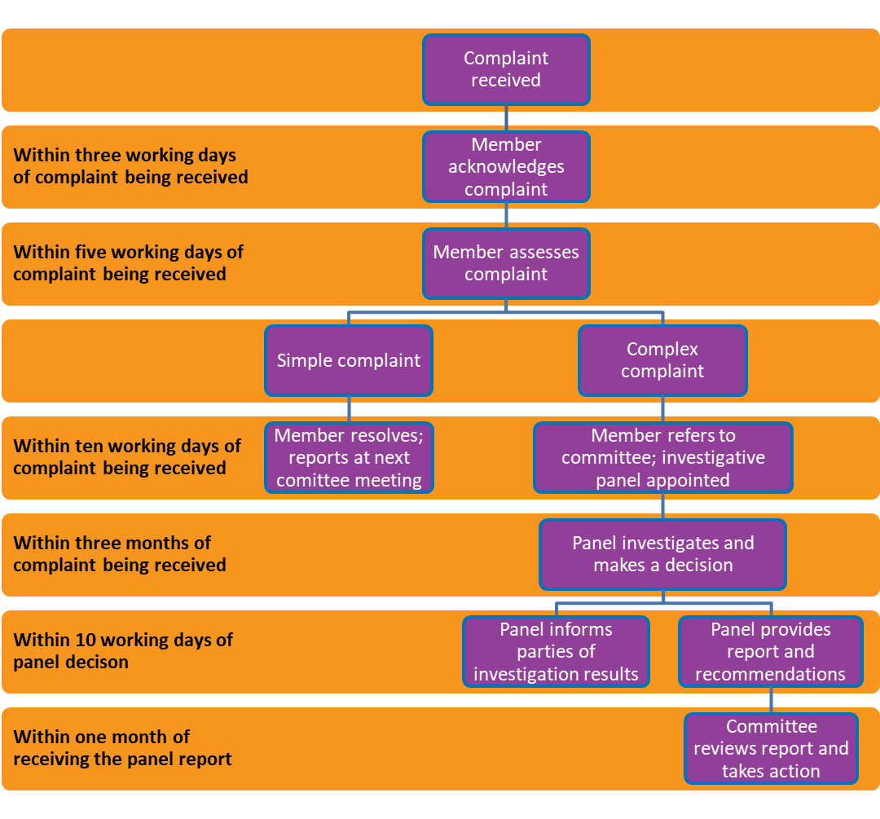
Simplified complaints policy process chart

