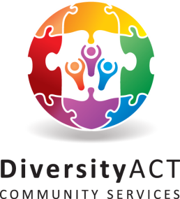Diversity ACT Community Services

PO Box 101

Erindale Centre ACT 2903

Ph: (02) 6231 3126

E: [info@diversityact.org](mailto:info@diversityact.org).au

ABN: 95 478 146 869

**www.diversityact.org.au**



Friday 19 October 2018

**For immediate release**

Diversity ACT would like to congratulate two of our members for winning Michael Firestone Memorial Scholarships during ACT Mental Health Month.

Delia Quigley and Siân Jackson were awarded their scholarships on 9 October 2018, at the Mental Health Month Awards at an event run by the Mental Health Community Coalition ACT (MHCC ACT). Awarded each year by MCHH ACT, the Michael Firestone Memorial Scholarships are granted to mental health consumers who wish to further their education but may not have the means to do so due to financial or other constraints. The Scholarship was established in recognition of Michael Firestone’s tireless efforts in assisting mental health consumers through information, education and referral, as well as his long personal battle with an education provider regarding his own issues of discrimination.

Delia is a retired AFP officer who has served as a peacekeeper in Timor Leste, Cyprus, Sudan, Haiti and on assistance missions in Jordan & the Solomon Islands. Stemming from her role is the AFP, she is living with PTSD and a number of other medical conditions. Delia is an outstanding contributor to the Canberra community – earlier this year she was recognised as the ACT Senior Volunteer of the Year for her work for Diversity ACT and Lifeline. Delia is also active in the Uniting Church, serving on a number of roles at the Presbytery and local church level.

Delia completed a 2-year part time Diploma of Counselling in 2017 and is now undertaking a Graduate Diploma in Relationships Counselling. She has been studying counselling part-time for the last three years, with the goal of providing free or low-cost counselling to low income clients of Diversity A.C.T. The funds from this scholarship will allow Delia to pay off her remaining course fees.

Siân Jackson is a young woman living with terminal illness and the comorbidity of mental illnesses as a flow on effect of that condition. Due to her medical restrictions, Siân receives a disability support pension (DSP). Despite the very raw deal her genetics have handed her, she is a source of light, joy and inspiration for all who know her. She uses physical performance as one component of her physical and mental health management strategy.

Siân is a flow performance artist and a photographer. Her major medium is fire and light – she dances with fire. You may have seen her in the recent Canberra Philharmonic Society production of Barnum. Her background in classical ballet, contemporary dance and instrumental music allow her to dramatically extend this art form. Siân has recently begun to explore circus performance as another field of artistic endeavour. Her long term goal is to study at the National Institute of Circus Arts (NICA).

To audition for NICA, Siân needs to develop additional traditional circus skills beyond her fire performance. She will begin Aerial classes at Circus Warehouse in Term Four, and is also investigating fields such as unicycling, Rola bola, hula hooping and juggling. Whichever field of circus she moves into, it will require the purchase of specialist clothing and equipment. Siân’s share of the funds from this scholarship will be spent on circus equipment such as LED Hula Hoops or Rola Bolas.

Diversity ACT and the Canberra LGBTIQ+ community are thrilled to see Delia and Sian’s success in their scholarship applications. We are confident that both these wonderful women and the wider community will benefit from their studies.

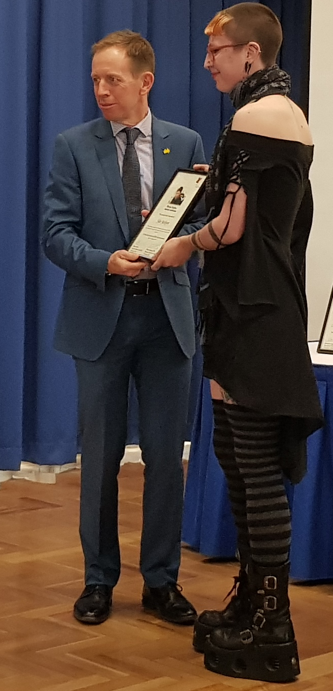

**Media enquiries**

Megan Jackson – 0416 191166, [info@diversityact.org.au](mailto:info@diversityact.org.au)